# Understanding probability - Exercises

## Q1. How many different possible values are there for a standard six-sided dice?



A:

## Q2. How many values of a six sided dice are less than 4?

Tip: Circle the values that are less than 4.



A:

## Q3. What is the probability of rolling a value less than 4 on a standard six side dice?

Tip: Count the number of “right” values and divide by the total number.

$p= \frac{Number of "right" values}{Total possible values}$ A:

## Q4. What is the probability of rolling at LEAST a 2 on a standard six side dice?

A:

## Q5. What is the probability of rolling a value less than 5 on a standard six side dice?

A:

## Q6. How many possible outcomes are there for rolling two fair six sided dice?

Tip: How many combinations are there in the picture below? (one dice is black, the other white)

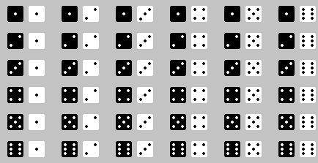

A:

## Q7. How many values (sum of the two dice) are less than 6?

Tip: circle all of the pair of dice rolls that sum to 2,3,4 or 5.



A:

## Q8. What is the probability of rolling a combination of 6 or less?

Tip: Count the number of “right” values and divide by the total number.

$p= \frac{Number ofc\text{orrect} values}{Total possible values}$ A: